Response Form to the Call for evidence on pre-hedging

Responding to this paper
ESMA invites comments on all matters in this consultation paper and in particular on the specific questions. Comments are most helpful if they:
- respond to the question stated;
- indicate the specific question to which the comment relates;
- contain a clear rationale; and
- describe any alternatives ESMA should consider.
ESMA will consider all comments received by 30 September 2022.
Instructions
In order to facilitate analysis of responses to the Consultation Paper, respondents are requested to follow the below steps when preparing and submitting their response:
- Insert your responses to the questions in the Consultation Paper in the present response form.
- Use this form and send your responses in Word format (pdf documents will not be considered except for annexes);
- Please do not remove tags of the type <ESMA_QUESTION _PHDG_1>. Your response to each question has to be framed by the two tags corresponding to the question.
- If you do not wish to respond to a given question, please do not delete it but simply leave the text “TYPE YOUR TEXT HERE” between the tags.
- When you have drafted your response, name your response form according to the following convention: ESMA_PHDG_nameofrespondent_RESPONSEFORM. For example, for a respondent named ABCD, the response form would be entitled ESMA_PHDG_ABCD_RESPONSEFORM.
- Upload the form containing your responses, in Word format, to ESMA’s website (www.esma.europa.eu under the heading “Your input – Open Consultations” -> Consultation Paper on the clearing and derivative trading obligations in view of the benchmark transition”).
Publication of responses
All contributions received will be published following the close of the consultation, unless you request otherwise. Please clearly and prominently indicate in your submission any part you do not wish to be publically disclosed. A standard confidentiality statement in an email message will not be treated as a request for non-disclosure. A confidential response may be requested from us in accordance with ESMA’s rules on access to documents. We may consult you if we receive such a request. Any decision we make not to disclose the response is reviewable by ESMA’s Board of Appeal and the European Ombudsman.
Data protection
Information on data protection can be found at www.esma.europa.eu under the heading Legal Notice.

Who should read this paper
All interested stakeholders are invited to respond to this call for evidence. This call for evidence is primarily of interest to investment firms, credit institutions, proprietary traders, market makers, asset management companies and in general persons operating on an ongoing basis in financial markets, but responses are also sought from any other market participants including trade associations and industry bodies, institutional and retail investors, consultants and academics.

General information about respondent
Name of the company / organisation | Swedish Securities Markets Association (SSMA)
Activity | Investment Services
Are you representing an association? | ☒
Country/Region | Sweden

Questions
- Do you agree with the proposed definition of pre-hedging with respect to case (i) and (ii)? Please explain elaborating if both case (i) and case (ii) in your view can qualify as pre-hedging and providing specific examples on both instances.
<ESMA_QUESTION_PHDG_1>
Yes, the SSMA agrees with the definition in case (i), further specified by its comment below on when pre-hedging is taking place. The SSMA believes that case (ii) should be further clarified, as it covers scenarios with different objectives for both client and dealer.

Also, the SSMA believes it to be important to clarify what constitutes a “trade proposal” and, equally important, when a transaction is “anticipated” and “potentially incoming”, as alluded to in chapter 2, paragraph 5 in the ESMA CfE. Any vagueness regarding these wordings may pose legal risks as they may be difficult to interpret and apply in practice.

As regards case (i), it may be worth considering the specific workflow of an RFQ, in an electronic trading context (however, the workflow would probably be similar for a non-electronic order, where a client interacts with the dealer through voice or chat functionality):
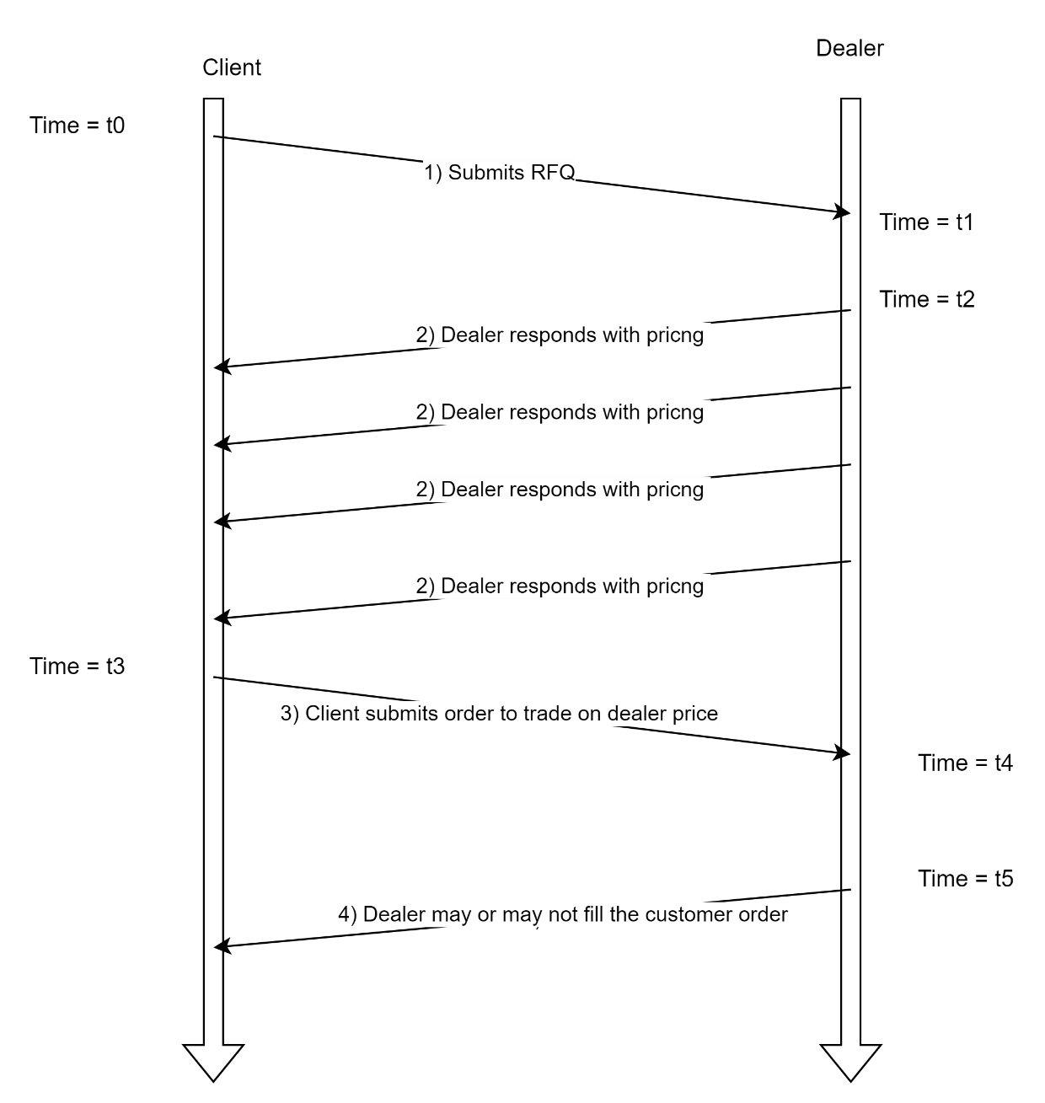

At time = t0, the client opens an RFQ (1), which is defined as an instruction to one or more dealers to provide a price for:

- A specific instrument(s)
- A specific amount(s)
- A specific tenor(s)
- Either a one-way (where clients specifics trade direction buy/sell) or two-way, which is a request for both prices to buy and sell.
- To a specific client account

The dealer(s) may upon reception of the order (at time = t1) choose to respond to the RFQ with a price (2) or a stream of prices (2) (at time = t2), depending on a nature of the RFQ, and whether the dealer re-prices the RFQ due to price changes in the underlying market.

At time = t3, the client may, after having observed the pricing from one or more dealers, choose to trade with a particular dealer. This takes the form of an order (3). At this stage the client has committed to the trade, should the dealer choose to accept that trade proposal.

From the time the dealer receives the order, at time = t4 to the time the dealer accepts or rejects the order (at time = t5), the order is in the state that is commonly known as Last Look.

The behaviour of the dealer between t4 and t5 is governed by the FX Global code, principle 17 on Last Look.

As such pre-hedging, in the context of RFQs, is a practice that takes place between time = t1 and time = t4.

As regards case (ii), it refers to situations where a client has submitted a “trade proposal”, but the trade will be agreed and executed at a later stage (in the case of a benchmark order), or where the trade has been agreed, but some elements of the trade will be specified at a later stage (in the case of an at-best order).

As case (ii) covers two distinct situations, benchmark and at-best, this may give grounds to divergence. Pre-hedging of benchmark orders may be in the client’s interest, or the interest of all market participants, as some benchmark orders, due to size and liquidity considerations, are not viable to execute within the specified timeframe of the benchmark. As an example, execution of large fixing orders within the fixing window, may lead to a price movement that is detrimental to the client’s final fill rate, and may disrupt the functioning of the market. On the other hand, pre-hedging of an at-best order, would not make sense, if it implies that the dealer is trading in the market ahead of the client order coming into effect. There are of course nuances, and an example would be that the dealer, with the knowledge of the pending order, decides to accumulate inventory, from other customer flows, which at a later stage can be used to partially fill the customer at-best order. This could lessen the market impact of the client order, which is in the client’s best interest.

Additionally, the SSMA asks for careful consideration as to whether the order/RFQ has been submitted to the dealer, or when it is merely anticipated or expected. Unless the order/RFQ has been submitted to the dealer by the client, any trading activity by the dealer should not be considered pre-hedging, since the definition of pre-hedging, in the Association’s opinion, only relates to trading activity after the RFQ has been submitted.

Furthermore, it is crucial that the definition of pre-hedging does not include all trading activities in the instrument or related instruments, during the time the order/RFQ is known/on-going. The activities that should be classified should only be related to activities that are in fact originating from the knowledge of the order.

On a similar note, there are several scenarios where it might look as if the dealer is pre-hedging, when it is in fact not, e.g., if the dealer assumes similar risk from elsewhere during the RFQ or order process. In such a case, the dealer cannot be expected to abstain from undertaking any trading activities, even with the knowledge of the pending RFQ or order – this would essentially encumber the dealer in an unreasonable situation without proper risk management options. In this regard, it is important to note that there is no upper limit for how long an RFQ can be under negotiation. It is not uncommon for this to be minutes. In this time-period the dealer must be able to trade on new market information, such as publicly available news, prices or trade history. The SSMA believes that it needs to be very clear that pre-hedging is solely tied to activities that have a direct correlation to the transfer of information inherent to the RFQ or order. The dealer must be allowed to process and perform several trading practices, e.g., automated RFQ, two-way quotes and general market movements, without risking being accused of engaging in front-running.

Finally, the SSMA would like to point out that it is important not to adopt a definition that may risk imposing (unintended) limitations on practices which should be considered allowed and beneficial to the market.
<ESMA_QUESTION_PHDG_1>

- Do you believe the definition should encompass other market practices? Please explain.
<ESMA_QUESTION_PHDG_2>
Not necessarily, but it is important to define when in the life cycle of a transaction the pre-hedging can be seen to take place.
<ESMA_QUESTION_PHDG_2>

- Do you agree with the proposed distinction between pre-hedging and hedging?
<ESMA_QUESTION_PHDG_3>
Yes, if the distinction is made on whether any hedging activities takes place before (pre-hedge) or after (hedge) the dealers final trade acceptance (time = t4 as shown in the SSMA’s schematic in the response to Q1), and that it clearly sets the boundaries between activities based on the RFQ/order itself, and what the dealer otherwise is doing, as outlined in the response to Q1.
<ESMA_QUESTION_PHDG_3>

- Do you have any specific concerns with respect to the practice of pre hedging being undertaken by liquidity providers when the trading protocol allows for a ‘last look’?
<ESMA_QUESTION_PHDG_4>
Not necessarily, but please be aware that principle 17 of the FXGC specifically states that any trading activity related to an order, during the last look window (between time = t3 and t4) is not allowed. Pre-hedging would take place before time = t3 (as shown in the SSMA’s schematic in the response to Q1), and therefore the two are not related.

In this regard, it should also be noted that there may be other checks, such as client permissions and checks on whether the order is correctly formulated that takes place.
<ESMA_QUESTION_PHDG_4>

- What is your view on the arguments presented in favour and against pre-hedging?
<ESMA_QUESTION_PHDG_5>
The SSMA believes it is necessary to note that there are important differences between case (i) and case (ii), and that different client interests are at stake in each of the cases. Therefore, they must be treated and analysed independently. As regards case (ii), the SSMA believes that pre-hedging must be allowed to facilitate for an efficient trading and market integrity, and to lower the transaction costs for the clients. As regards case (i), the SSMA believes that the risk of infringing client interests may be more of a factor compared to case (ii). However, it is nevertheless important for dealers to be able to neutralise their risk through pre-hedging in such situations as well.

As regards chapter 3, paragraph 18 in the ESMA CfE, the SSMA believes it to be correct if applied to RFQs only. An example of the mentioned competitor distortions could be the winners curse, but whether this constitutes a breach of the integrity of the market is an open question as other competitors may already have inventory.

As regards chapter 3, paragraph 25 in the ESMA CfE, the SSMA does not really see how this differs from front-running. The party would not have undertaken the actions without the RFQ (non-public knowledge = potential inside information) of the potential transaction.
<ESMA_QUESTION_PHDG_5>

- In which cases could a foreseeable transaction enable a conclusion to be drawn on its effect on the prices?
<ESMA_QUESTION_PHDG_6>
Not possible to provide an all-encompassing answer because it can depend on multiple factors, e.g., relevant financial instrument, liquidity, size, trade history of the client, estimate of client positions in the relevant instrument or derivatives of the instrument.
<ESMA_QUESTION_PHDG_6>

- Do you agree that an RFM when the liquidity provider could discover the trading intentions of the sender on the basis of their past commercial relationship, the market conditions or the news flow should be considered as precise information?
<ESMA_QUESTION_PHDG_7>
No, the SSMA does not agree that an RFM generally should be considered as precise information. However, as regards chapter 4, paragraph 16 in the ESMA CfE, this could be the case for certain clients or client segments. Some segments would have an affinity for trading in a certain direction. Although this is not a certainty, there will be an uneven probability of a buy or sell order from the client(s).
<ESMA_QUESTION_PHDG_7>

- Please provide your views regarding the criteria for the identification of RFQs that could potentially have a significant impact on the price of the relevant financial instrument. Is there any other criterion that ESMA should take into account?
<ESMA_QUESTION_PHDG_8>
It is difficult to set an exhaustive list, but it should generally be determined on a case-by-case basis, weighing in multiple factors, e.g., market conditions (volatility, liquidity and time of day) and size. However, liquidity in the relevant instrument and the size of the order would most likely be the most important factors.

As regards chapter 4, paragraph 20 in the ESMA CfE, the SSMA believes the realised profit of engaging in pre-hedging activities depends on trade size. As such, it would happen more with larger RFQs. Larger trades would also carry more market impact, and as such be more detrimental to the client.
<ESMA_QUESTION_PHDG_8>

- Does the GFXC Guidance describe all the possible cases of risk management rationale that could justify legitimate pre-hedging? If not, please elaborate
<ESMA_QUESTION_PHDG_9>
The proposed reasons for risk management does not seem reasonable, at least in the FX markets.

One argument supporting pre-hedging as a reasonable risk management tool, relates to the potential risk the dealer may assume from quoting prices elsewhere while an RFQ is under negotiation. Since the dealer may end up trading with the customer that has submitted the RFQ, the dealer also is providing prices to other clients, as well as potentially the street. This entails that the dealer might be at risk of assuming more risk at any one given time, than the dealer is willing to accept. A natural reaction would be for the dealer to provide less liquidity to the market, in form of quotes and orders, until the actual risk is determined (once the client RFQ has been dealt, or not).

In this case, the dealer is not necessarily doing actual trades in the market based on the RFQ or order, but the supply/demand imbalance the dealer creates may affect the general price formation in the market. It is important to note that it is not a given fact that the market price may be impacted, and the price would move against the customer on the RFQ, as other dealers reprice – there are clearly scenarios where this would not happen, mainly based on who the dealer retracts liquidity from.
<ESMA_QUESTION_PHDG_9>

- Can you identify practical examples of pre-hedging practices with/without a risk management rationale?
<ESMA_QUESTION_PHDG_10>
For the two cases subject to this consultation, it seems the only reasonable place to perform pre-hedging is when executing benchmark orders under case (ii), except for the scenario outlined in the response to Q9, if this is in fact to be designated as pre-hedging. This would be done to shield the client and the dealer from market impact, which would be detrimental to the clients end rate, and non-necessary disruptions of the market. Dealers should not position their inventory ahead of a customer order, if that has an adverse effect on the price formation in the market, as seen from the client perspective.
<ESMA_QUESTION_PHDG_10>

- Can pre-hedging be considered legitimate when the market participant is aware, on the basis of objective circumstances, that it will not be awarded the transaction?
<ESMA_QUESTION_PHDG_11>
No.
<ESMA_QUESTION_PHDG_11>

- Can you identify financial instruments that should/should not be used for pre-hedging purposes? Please elaborate
<ESMA_QUESTION_PHDG_12>
No, not possible to categorise in such a way.
<ESMA_QUESTION_PHDG_12>

- Please provide your views on the proposed indicators of legitimate and illegitimate pre-hedging. Would you suggest any other?
<ESMA_QUESTION_PHDG_13>
It is the SSMA’s view that pre-hedging is done to facilitate, or make possible, transactions for the customers. It is difficult for the SSMA to list any other suggestions.
<ESMA_QUESTION_PHDG_13>

- According to your experience, can express consent to pre-hedging be provided on a case-by-case basis in the context of electronic and competitive RFQs? If yes, how? Do you think the client’s consent to pre-hedging should ground a presumption of legitimacy of the liquidity provider’s behaviour?
<ESMA_QUESTION_PHDG_14>
It would be possible to pass consent on electronic channels. Generally speaking, clients would engage electronically with the dealer through three different means:
1) Single dealer platform
2) Multi dealer platform
3) API

In all cases, it would be possible to define a property in the RFQ submission workflow, whereby the client could specify whether they opt in or out.

The discussion on pre-hedging is about protecting the client. If the client explicitly opts in to pre-hedging, on the assumption that they will get a better price or higher fill rate, then this should be at the clients discretion to do so.
<ESMA_QUESTION_PHDG_14>

- Could you please indicate which are in your view the pre-hedging practices that appear to be conducted mostly in the interest of the liquidity provider and which may risk to not bring any benefit to the client?
<ESMA_QUESTION_PHDG_15>
Only for case (i) would this primarily be in the interest of the dealer only. Except case (ii) benchmark, then all of the practices are in the dealer’s interest.
<ESMA_QUESTION_PHDG_15>

- Do you think it would be feasible for liquidity providers to provide evidence of (i) their reasonable expectation to conclude the transaction; (i) the risk management needs behind the transactions; (iii) the benefit for the client pursued through the transaction and (iv) the client’s consent? If no, please indicate potential obstacles to the provision of such evidence.
<ESMA_QUESTION_PHDG_16>
- No, dealer would not know whether they would win an RFQ, or whether the client would even deal in the end.
- No, on a case-by-case basis, the SSMA cannot see how a dealer would be able to provide evidence of risk management needs, notwithstanding the dealer’s own position, which might be the reason to pre-hedge in the first place.
- No, this would imply that the dealer would be able to calculate the cost for the client with or without the pre-hedge. This is not possible, since it would require a precise knowledge of the market impact of the trades done in the pre-hedging process. This can be statistically described, but not in detail for a specific transaction.
- Yes.

The SSMA fears that additional rules requiring dealers to provide evidence of reasons to pre-hedge (other than the client’s consent), would risk hampering the markets to the detriment of customers.
<ESMA_QUESTION_PHDG_16>

- Do you believe that the liquidity of a financial instrument should be considered as an indicator in determining whether pre-hedging may be illegitimate behaviour? Please elaborate.
<ESMA_QUESTION_PHDG_17>
Liquidity in itself should not be a decisive indicator for whether pre-hedging constitutes illegitimate behaviour.
<ESMA_QUESTION_PHDG_17>

- According to your experience does the practice of pre-hedging primarily take place in what is described as the ‘wholesale markets’ space or does this practice take place also with respect to order / RFQs submitted by retail or professional clients?
<ESMA_QUESTION_PHDG_18>
To the SSMA’s understanding, pre-hedging mostly takes place within the wholesale markets, however pre-hedging, as described in case (i), is not frequently occurring at all.
<ESMA_QUESTION_PHDG_18>

- As an investment firm conducting pre-hedging, do you have any internal procedure addressing the COI which might arise specifically from such practice? If yes, please briefly explain the content of such procedure.
<ESMA_QUESTION_PHDG_19>
No answer.
<ESMA_QUESTION_PHDG_19>

- According to current market practice, do investment firms disclose to clients that their RFQs might be pre-hedged? If so, does this happen on a case-by-case basis (i.e. a client is informed that a specific order might be pre-hedged) or is this rather a general disclosure? Please elaborate, distinguishing between various trading models, e.g. voice trading vs electronic trades and please specify if there are instances in which RFQ systems allow to specify is pre-hedging is conducted?
<ESMA_QUESTION_PHDG_20>
In FX, the use of pre-hedging is discussed in the FXGC, and usually it would be disclosed to clients in a general sense in the dealer’s available disclosures. The SSMA does not know of instances where it is possible for clients to specify this on order entry.
<ESMA_QUESTION_PHDG_20>

- According to current market practice, are clients offered quotes with and without pre-hedging, leaving to the client a choice depending on his execution preferences? Is so in which instances?
<ESMA_QUESTION_PHDG_21>
Not to the SSMA’s knowledge, however there are generally discussions on quotes with the customer as regards, e.g., volume and markets conditions.
<ESMA_QUESTION_PHDG_21>

- Do you currently keep record of pre-hedging trades and related trading activity? Do you believe record keeping in this instance would be easy to implement?
<ESMA_QUESTION_PHDG_22>
Yes, to some workflows specific to case (ii), benchmark orders that need to be pre-hedged are documented. It will be impossible to, on a higher level, keep track of which trades and orders relate to pre-hedging.

However, the dealers are already subject to record-keeping rules under, e.g., MiFID II, and the SSMA fears that additional rules would risk hampering the markets to the detriment of customers.
<ESMA_QUESTION_PHDG_22>

- Would you like to highlight any specific issue related to the obligation to provide clear and not misleading information?
<ESMA_QUESTION_PHDG_23>
No, not for now.
<ESMA_QUESTION_PHDG_23>

- Should ESMA consider any other element with respect to pre-hedging and systematic internalisers and OTFs? Please elaborate
<ESMA_QUESTION_PHDG_24>
No, the SSMA fears that additional rules would risk hampering the markets to the detriment of customers.
<ESMA_QUESTION_PHDG_24>

